1、 查看官网的 MySQL 5.7安装包下载
官方下载地址：https://dev.mysql.com/downloads/mysql/5.7.html#downloads
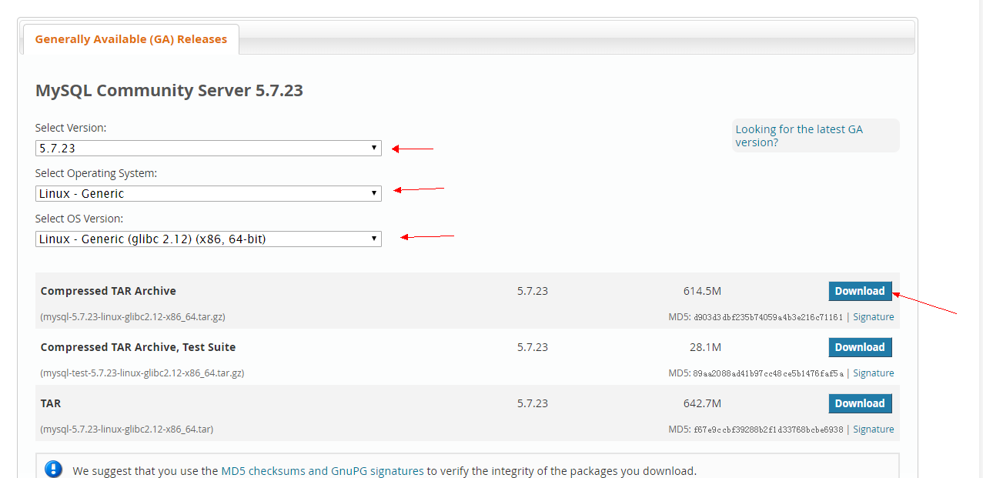

需要下载的安装包包名:
mysql-5.7.23-linux-glibc2.12-x86_64.tar.gz

rpm -qa |grep mysql

创建mysql文件夹
mkdir /usr/local/mysql
mkdir /usr/local/mysql/data

进入local:
cd /usr/local/src

MySql各个版本下载地址

社区办:https://downloads.mysql.com/archives/community/
安装板:https://downloads.mysql.com/archives/installer/
下载社区版:(600M左右,下载需要点时间)
wget
https://cdn.mysql.com/archives/mysql-5.7/mysql-5.7.23-linux-glibc2.12-x86_64.tar.gz

解压到当前目录:
tar -xzvf mysql-5.7.23-linux-glibc2.12-x86_64.tar.gz

移动文件到/usr/local/mysql:
mkdir -p /usr/local/mysql
mv mysql-5.7.23-linux-glibc2.12-x86_64/* /usr/local/mysql
mkdir -p /usr/local/mysql/binlog

添加用户组, 创建mysql用户添加到mysql组:
groupadd mysql
useradd -g mysql mysql

设置mysql文件夹权限
chown -R mysql.mysql /usr/local/mysql/

mysql的服务脚本放到系统服务中:
cp -a /usr/local/mysql/support-files/mysql.server /etc/init.d/mysqld

复制配置文件到 /etc/my.cnf
cp -a ./support-files/my-default.cnf /etc/my.cnf
(注意 : 5.7.23解压后没看到my-default.cnf, 可跳过该步骤,直接下一步)

修改my.cnf: 配置不对的话,后面初始化不全,会拿不到默认密码
vim /etc/my.cnf

修改内容:
[mysqld]
basedir = /usr/local/mysql
datadir = /usr/local/mysql/data
port = 3306
socket = /tmp/mysql.sock
character-set-server = utf8
log-error=/usr/local/mysql/mysqld.log
pid-file=/usr/local/mysql/mysqld.pid
lower_case_table_names=1
event_scheduler = 1

server-id=1022
log-bin=/usr/local/mysql/binlog/mysql-bin.log
sql_mode = "STRICT_TRANS_TABLES,NO_ZERO_IN_DATE,NO_ZERO_DATE,ERROR_FOR_DIVISION_BY_ZERO,NO_AUTO_CREATE_USER,NO_ENGINE_SUBSTITUTION"
log_bin_trust_function_creators=1
确保上面配置文件都是存在的,且有修改权限.

查看mysql文件权限:
cd /usr/local/mysql/
ls -l

安装和初始化数据库(重要)

首先要进入bin文件:
cd /usr/local/mysql/bin/

初始化:

./mysqld --initialize --user=mysql --basedir=/usr/local/mysql/--datadir=/usr/local/mysql/data/

安全启动:
./mysqld_safe --user=mysql &

先进入cd support-files文件:
cd /usr/local/mysql/support-files/

把support-files/mysql.server 拷贝为/etc/init.d/mysql
cp mysql.server /etc/init.d/mysql

并设置运行权限

chmod +x /etc/init.d/mysql

把mysql注册为开机启动的服务
chkconfig --add mysql && chkconfig --list mysql

启动:
service mysql start

默认密码在mysqld.log日志里, 找到后保存到安全的地方:

grep tem /usr/local/mysql/mysqld.log

其中root@localhost: 后面的就是默认密码,后面登录用.(如果找不到可能默认是空,登录时密码直接回车,否则可能安装有问题)

进入bin文件:
cd /usr/local/mysql/bin/

登录mysql:
./mysql -u root -p

上面登录必须要指定mysql路径,下面设置通用启动,做个链接即可:
ln -s /usr/local/mysql/bin/mysql /usr/bin/mysql

然后启动方法可以用:
mysql -u root -p

回车后输入刚才的密码,回车:

假设修改密码为abc123(注意结尾加冒号):
mysql> set password=password("qwe123");

设置远程登录权限
mysql> grant all privileges on *.* to 'root'@'%' identified by 'qwe123';
Query OK, 0 rows affected, 1 warning (0.00 sec)

立即生效:
mysql> flush privileges;
Query OK, 0 rows affected (0.06 sec)

退出quit; 或者 exit;
mysql> quit;
参考文档：https://www.jianshu.com/p/061d253ab7b4

